Project Plan

Project Title
Research Question
Objectives
Motivations
Summary and Background
References

Project Title

Deepfake Face Detection of Human Face Images by Generative Adversarial Networks

Detection for Human Face Images by Generative Adversarial Networks

Research Questions

. How do different evaluation metrics such as precision, recall, and F1-score reflect the performance of deepfake face detection models, and which metrics are most suitable for assessing their effectiveness in real-world scenarios?
. How effective are Generative Adversarial Networks (GANs) in generating realistic deepfake human faces compared to traditional methods?
. What are the key challenges in accurately detecting deepfake faces generated by GANs amidst rapidly advancing deepfake technology?

How do different evaluation metrics such as precision, recall, and F1-score reflect the performance of deepfake face detection models, and which metrics are most suitable for assessing their effectiveness in real-world scenarios?

In evaluating deepfake face detection models, precision, recall, and F1-score each highlight different performance aspects. Precision measures the accuracy of positive predictions, crucial when false positives are costly, such as in legal contexts. Recall assesses the model's ability to identify actual deepfakes, vital in scenarios were missing a deepfake has severe consequences, like in social media moderation. The F1-score balances precision and recall, providing a holistic view of the model's effectiveness, making it suitable when both types of errors are equally important. The choice of metric depends on the specific application and the relative costs of false positives and false negatives in that context.

How effective are Generative Adversarial Networks (GANs) in generating realistic deepfake human faces compared to traditional methods?

Generative Adversarial Networks (GANs) are highly effective in generating realistic deepfake human faces, significantly surpassing traditional methods. GANs leverage a dual-model framework where a generator creates images and a discriminator evaluates their authenticity, iteratively refining the generated faces to achieve high realism. This adversarial process allows GANs to produce deepfakes with intricate details and subtle nuances, making them far more convincing than those created by earlier techniques, which often lacked such refinement and complexity.

What are the key challenges in accurately detecting deepfake faces generated by GANs amidst rapidly advancing deepfake technology?

Detecting deepfake faces generated by GANs faces several key challenges due to the rapid advancement of deepfake technology. These challenges include the increasing sophistication of GAN-generated images, which exhibit high levels of detail and realism that can easily deceive both human eyes and automated detectors. Additionally, the constant evolution of GAN architectures makes it difficult to develop static detection methods, necessitating continuous updates and improvements to detection algorithms. The subtle artifacts left by GANs are becoming harder to identify as technology improves, and the vast diversity in potential manipulation techniques further complicates the development of robust detection systems.

Objectives

. Explored method to distinguish real and fake faces generated by DCGANs.
. Used CNN for face detection.
. Used confusion matrices and AUROC curves as tools to analyze and visualize the performance of the models.
. These tools have proved effective in enhancing GAN-generated face detection.

Motivations

Creating tools to protect us from tricky computer stuff that can be used the wrong way.
Making computer models smarter to recognize real faces and not get manipulated.
Helping to keep the internet safer by finding and stopping fake faces using smart tools.
This technological advancement is crucial for safeguarding individuals and institutions against the adverse effects of deepfakes, ensuring the integrity of digital media, and fostering trust in digital communications.

Background

What are GANs?
GANs stand for Generative Adversarial Networks:
Generative: Capable of generating new data instances.
Adversarial: Involving competition or conflict between two entities, in this case, neural networks.
Network: A system of interconnected nodes or units, discussion of the neural network architecture used in GANs.

Background cont....

In 2014, Ian Goodfellow, along with his colleagues, proposed the concept of Generative Adversarial Networks. The paper titled "Generative Adversarial Nets" was published by Goodfellow and his collaborators. It's like a game between two networks: one, called the generator, makes fake stuff, and the other, called the discriminator, decides if it's real or fake. They both get better by playing this game, with the generator trying to make more realistic things and the discriminator getting better at telling what's real.
Deepfake:
The term "deepfake" is a combination of “deep learning” and “fake”. Deepfake refers to a type of media that is created using deep learning techniques, particularly with the use of artificial intelligence models such as Generative Adversarial Networks (GANs). These AI algorithms analyze and learn patterns from large datasets, allowing them to generate highly realistic and convincing fake content, often involving the modification of images, videos, or audio. Fake videos and pictures, called deepfakes, make people worried because they can be used to spread lies, steal someone's identity, and invade privacy. To deal with this, people are working hard to create tools and methods that can find and reduce the harm caused by these fake contents.

Summary

Utilize the FFHQ dataset for training and evaluating the models containing real facial images.
Employ Generative Adversarial Networks (GANs) type, namely DCGANs, to generate synthetic facial images.
Choose deep learning model for the identification of deepfake faces that is Convolutional Neural Networks (CNNs).
Calculate accuracy values for each model to measure their performance in distinguishing between real and deepfake images.
Use confusion matrices and Area Under the Receiver Operating Curve (AUROC) to check how well the models are doing. This helps us understand and measure how good the models are at telling real images from fake ones.

Data Management Plan

Data Collection.
Flickr Faces 70k Thumbnails 128x128 (kaggle.com)
Overview and Summary of dataset.
The Flickr-Faces-HQ (FFHQ) dataset, released by Nvidia Research in October 2018, comprises high-resolution face images sourced from Flickr, a photo-sharing platform. The dataset's creation involved automated web scraping techniques to gather images tagged with relevant keywords, followed by rigorous curation to ensure quality and relevance. The FFHQ (Flickr-Faces-HQ) dataset is a high-quality collection of 70,000 human face images, each at a resolution of 128x128 pixels in png format, totaling approximately 2 GB. These images feature diverse variations in age, ethnicity, and background, organized in subdirectories
Documentation.
Abdul-moe/Abdul-moe at my-project (github.com)
Metadata
Abdul-moe/README.md at my-project · Abdul-moe/Abdul-moe (github.com)
Security and Storage.
To ensure security and proper storage of the FFHQ dataset, access will be restricted to authorized personnel using multi-factor authentication, and data will be encrypted in transit and at rest. Regular backups will be performed daily with weekly offsite backups, and versioning will be enabled.

Loss Function

The basic GANs loss function is:
$\min_{G}{\max_{D}{V\left(D,G\right)=E_{x\sim pdata}\left[\log\left(D\left(x\right)\right)\right]+}}E_{z\sim p_{z}}\left[\log\left(1-D\left(G\left(z\right)\right)\right)\right]$
where:
D is the discriminator function.
G is the generator function.
x represents real data.
z represents noise sampled from a distribution pz.
This loss function encourages the generator to produce samples that are indistinguishable from real data according to the discriminator.

Method for Detection

Use model (CNN) to find fake images.
Training process undertaken for each model to learn features and patterns from the dataset.
Accuracy values obtained as performance metric after training.
To understand their performance, we used a chart (confusion matrix) that shows if they were right or wrong.
Another chart (AUROC curve) helped us see how well they could tell fake from real images.
Our research highlights challenges in deepfake techniques and solutions found by face detection algorithms.

References

Do, N. T., Na, I. S., & Kim, S. H. (2018). Forensics face detection from GANs using convolutional neural network. ISITC, 2018, 376-379.
Tolosana, R., Vera-Rodriguez, R., Fierrez, J., Morales, A., & Ortega- Garcia, J. (2020). Deepfakes and beyond: A survey of face manipulation and fake detection. Information Fusion, 64, 131-148.
Korshunov, P., & Marcel, S. (2018). Deepfakes: a new threat to face recognition? assessment and detection. arXiv preprint arXiv:1812.08685.
Kohli, A., & Gupta, A. (2021). Detecting deepfake, faceswap and face2face facial forgeries using frequency cnn. Multimedia Tools and Applications, 80, 18461-18478.

Project Plan

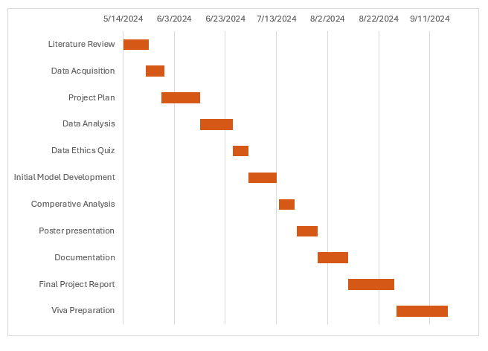

Project Timeline

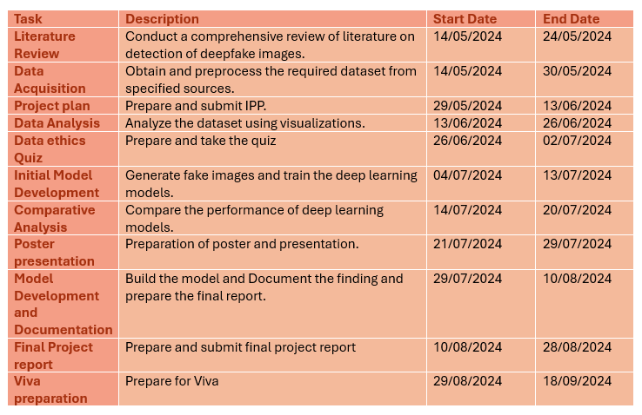

Thank You

